Download the Global Protect client

<https://www.mcguiregroup.net/globalProtect64.msi>

Once the client is installed connect to **vpn2.mcguiregroup.com**

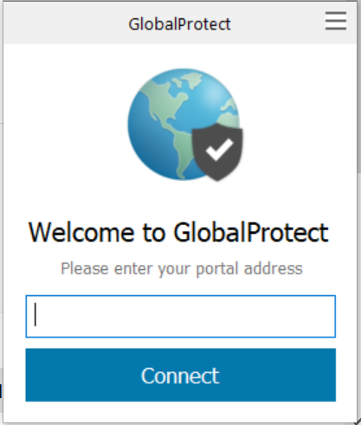

Sign in with your credentials.

Once connected you can now RDP to Rage1

To sign out of the Global Protect Client just right click on it and click the setting bars on the top right 

choose settings and then sign out.